1. **What is REST?**  
   A) One use of PUT and DELETE together with GET and POST that has become popular recently is referred to by the common term ”REST”  
   B) The term REST was coined by Roy Fielding in his Ph.D. dissertation and means Representational State Transfer. REST describes web applications that request and manipulate web resources using the standard HTTP methods **GET, POST, PUT and DELETE**
2. **What is a Resourse?**  
   A resource in the context of REST is *a URL-addressable entity that offers interaction via HTTP*.  
   In the context of a Rails application, *a resource is a combination of a dedicated controller and a model*.

|  |
| --- |
| How does it work:  A single entry in the routing file, such as **resources :photos** |

creates seven different routes in your application, all mapping to the Photos controller:

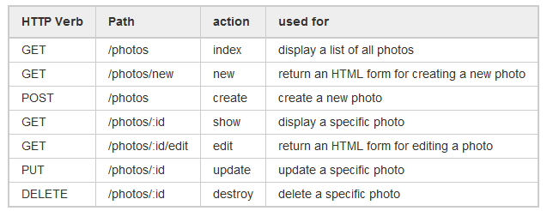

The HTTP verb determines which action will be executed.

Note that there is some overlap in the URLs; for example, both **show**, **update, and destroy** actions correspond to the URL /photos/:id. The difference between them is the HTTP request method they respond to. In other words – action can correspond to the same page, but respond to a different http method.

Creating a resourceful route will also expose a number of helpers to the controllers in your application. In the case of resources :photos:

photos_path returns /photos  
new_photo_path returns /photos/new  
edit_photo_path(:id) returns /photos/:id/edit (for instance,edit_photo_path(10) returns /photos/10/edit)  
photo_path(:id) returns /photos/:id (for instance, photo_path(10) returns/photos/10)

